Netflix Movie Recommendations
Netflix offers thousands of movies and TV shows, which can make it hard for users to decide what to watch. To solve this problem, this project focuses on creating a movie recommendation system that suggests movies based on user preferences.
Using the Netflix Movies & TV Shows dataset, the project explores data such as genres, ratings, and release years to understand viewing trends. Then, techniques like TF-IDF (Term Frequency–Inverse Document Frequency) and cosine similarity are used to recommend movies that are similar to what a user has already watched or liked.
Objective or Problem statement
The goal of this project is to develop an intelligent Netflix movie recommendation system that helps users discover content aligned with their viewing preferences. By analyzing and processing the Netflix Movies & TV Shows dataset, the project aims to uncover patterns in user behavior, identify popular genres, and generate personalized recommendations.
The system will address the challenge of information overload on streaming platforms, where users often struggle to find relevant content among thousands of titles. Through data cleaning, exploratory analysis, and machine learning techniques such as TF-IDF vectorization and cosine similarity, the project seeks to improve user satisfaction by suggesting movies and TV shows that match their interests and historical preferences.
Tools and Technologies Used
• Python – for data analysis, preprocessing, and building the recommendation system
• Pandas – for data manipulation and cleaning
• NumPy – for numerical computations
• Matplotlib and Seaborn – for data visualization and exploratory analysis
• Scikit-learn – for implementing TF-IDF and cosine similarity
• VS Code – as the coding and analysis environment
• CSV Dataset (Netflix Movies & TV Shows) – as the primary data source

Dataset Used
The dataset used for this project is the Netflix Movies & TV Shows dataset sourced from Kaggle. It contains information about over 8,800 records of movies and TV shows available on Netflix, including details such as title, director, cast, country, release year, rating, and genre.
This dataset provides both categorical and textual data, which is ideal for building a content-based recommendation system using techniques like TF-IDF and cosine similarity.
Methodology
- Data Collection
- The Netflix Movies & TV Shows dataset was imported from Kaggle. It includes details such as title, genre, cast, director, and release year for analysis.
- Data Cleaning
- Duplicate records and missing values were handled. Text fields like titles and genres were standardized to maintain consistency.
- Data Preprocessing
- Combined multiple text features (title, cast, genre) into a single field to prepare the dataset for feature extraction.
- Feature Extraction
- Used the TF-IDF technique to convert text data into numerical vectors, enabling similarity calculations between movies.
- Model Building
- Implemented cosine similarity to find and recommend movies or shows similar to the one selected by the user.

- Visualization
- Generated charts and trend analysis using Python libraries (Matplotlib, Seaborn) to better understand genre distribution and ratings.
- Output / Deployment
- The final system provides personalized Netflix movie recommendations based on content similarity.
Features Implemented/ Key Visuals
- Movie Recommendation System – Built a content-based recommendation model using TF-IDF and cosine similarity to suggest movies similar to the user’s choice.
- Genre Analysis – Visualized the most popular genres and their frequency using bar charts and count plots.
- Rating and Year Trends – Analyzed how movie releases and user ratings have changed over different years.
- Data Insights Dashboard – Displayed visual insights such as top genres, release year distribution, and type-wise (Movie/TV Show) count using Python visualization libraries.
- User Personalization – Generated customized movie suggestions based on user viewing patterns and preferences.
Results/ Key Insights
- The model successfully recommends movies and TV shows similar to the user’s selected title based on genre, cast, and description.
- Analysis revealed that Drama, Comedy, and Action are the most common genres on Netflix.
- Most content was released between 2015–2021, showing a rapid growth in Netflix’s content library during this period.
- The majority of Netflix content comes from the United States, India, and the United Kingdom, highlighting regional dominance.
- The recommendation system improved user experience by providing accurate and relevant movie suggestions using TF-IDF and cosine similarity.

Challenges Faced
- Faced missing and duplicate data in the dataset, which was solved through data cleaning and preprocessing using Python (Pandas).
- Encountered text formatting issues in titles and genres, handled by converting text to lowercase and removing extra spaces.
- Dealt with high dimensionality during TF-IDF vectorization, resolved by limiting the number of features and optimizing cosine similarity calculations.
- Difficulty in balancing recommendations across genres was improved by combining multiple text attributes like cast, director, and genre for better accuracy.
Conclusion
This project provided valuable insights into how data-driven techniques can be applied to personalize user experiences on streaming platforms. By cleaning, exploring, and analyzing the Netflix dataset, I was able to understand viewer preferences, popular genres, and trends across different years. Implementing TF-IDF and cosine similarity techniques enabled the creation of a functional movie recommendation system that suggests content aligned with user interests.
This project helped improve my skills in data cleaning, EDA, and storytelling using data. It also strengthened my understanding of machine learning concepts like similarity measures and recommendation algorithms. Overall, this project was an excellent opportunity to combine analytical thinking with practical implementation to solve a real-world problem effectively.

Screenshots
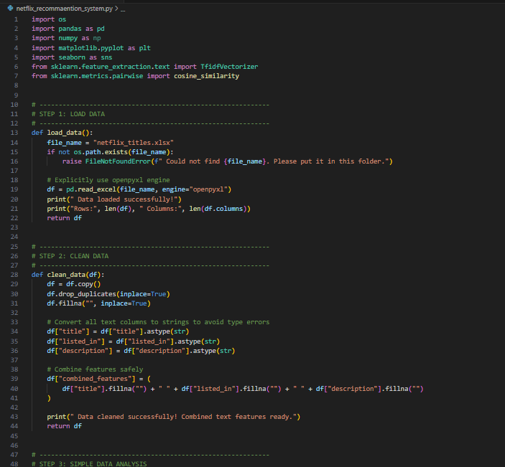
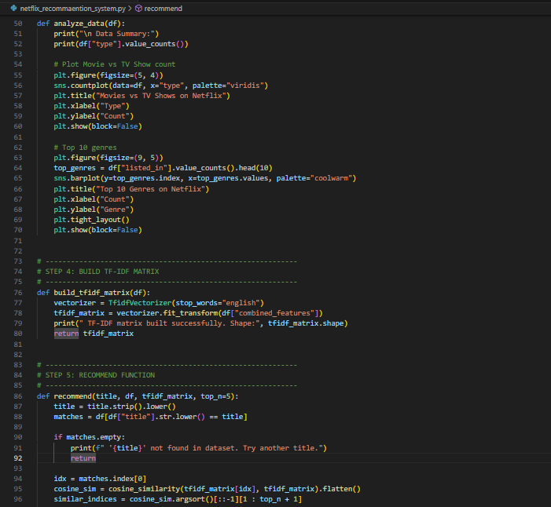
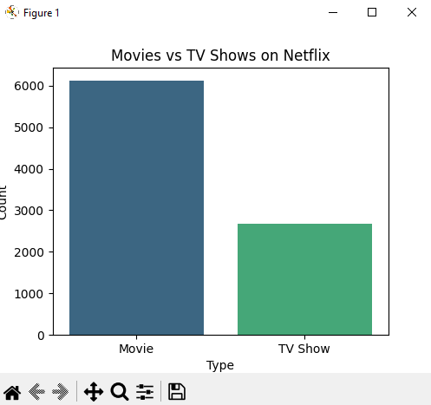
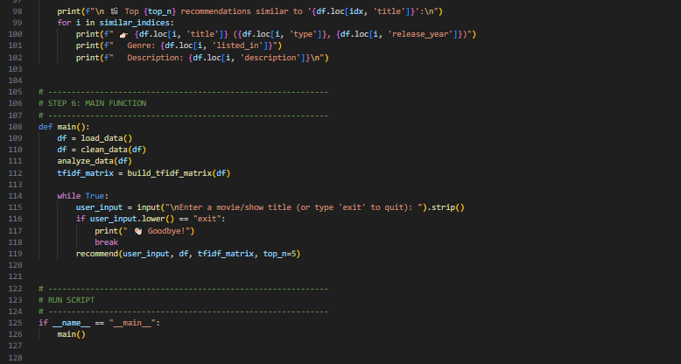
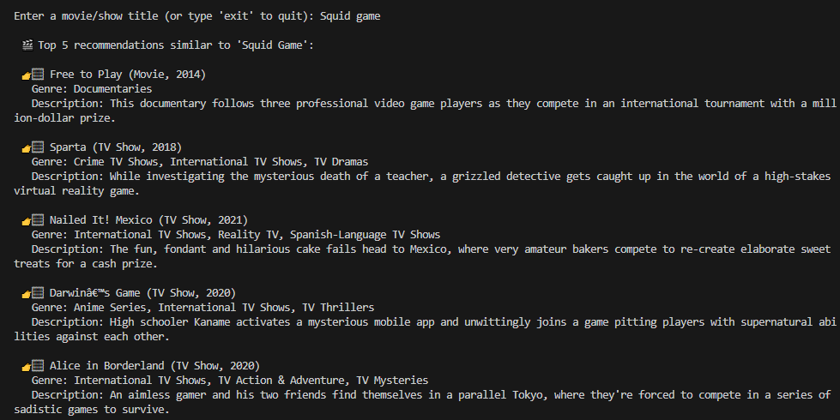
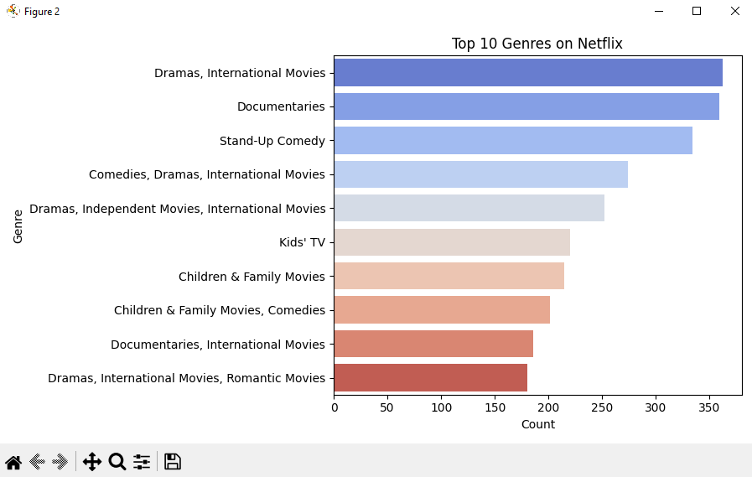
Link to GitHub
GitHub: https://github.com/Yashu-teach/Netflix-Movie-Recommendations-Project

